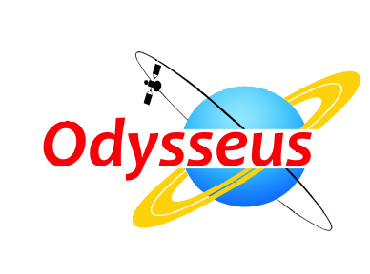
PRESS RELEASE
22 May 2013
For Immediate Release

Winners announced in the Pan-European Educational Contest on Space Exploration
The top prizes were awarded to school teams from Slovakia, Greece, UK, Romania and Norway in recognition of outstanding effort and achievement in science.
The winners of the European educational contest, Odysseus, received their prizes at a ceremony held in Space Expo, in Noordwijk, the Netherlands. The winning teams from Slovakia, Greece, United Kingdom, Romania and Norway were invited in the European Astronaut Centre (EAC) in Cologne, Germany, where they enjoyed a guided tour in the astronauts training facilities, met with astronauts and learned all about the recruitment and training of ESA’s astronauts for space missions. The next day the teams visited the Space Expo, where they discovered the world of space exploration and presented their projects.
Odysseus contest, which was co-funded by the European Commission, within the Seventh Framework Programme (FP7) in the Space area was developed to challenge talented young people on science and to engage and inspire the European youth in discovering the answers to fundamental questions about the history of earth, the origin of life, the solar system and the universe. 119 teams of pupils between 14 and 18 years old from 18 countries competed in the Odysseus contest, which ran from July 2012 to February 2013. The contestants all developed a project, using their knowledge, creativity and critical thinking, in one of the three themes of the contest: Solar System, Spaceship global cooperation and Co-evolution of life.
The winning teams in the three themes were selected among the national finalists in each theme and after careful review and consideration by a panel of distinguished space experts, scientists and astronauts. One team who was voted by the participating teams as the participants’ favourite entry and one team, who won the prize for the non-EU countries, joined the three finalists in the award ceremony.
“The purpose of the Odysseus contest” said Ms Elena Tavlaki, coordinator of the project and director of SIGNOSIS, “is to increase awareness of the importance of space exploration and to inspire pupils to consider space and science in their future career". “The contest also encouraged young students to collaborate with other students, teachers and the community and promoted a hands-on science approach that showed to students that space is fun, and relevant to everyone.”

The winners in each theme category are as follows:
Solar system theme:
“lLost” team from the Gymnasium Hubeneho of Bratislava, Slovakia, with the project “An Abundance Comparison and Distribution of C, S, O and noble gasses He, Ar and Ne in the Atmosphere of Jupiter”
Co-evolution of life theme:
“Exoplants” team from Pelopium Lyceum, Greece, with the project “What colour would plants have on another planet?”
Spaceship – Global cooperation theme:
“Bay House School” team from the United Kingdom with the project “INTERcore”
Participants’ Voting:
“ORION IMS” team from the Tudor Vianu National High School of Computer Science, Romania, with the project “Orion Innovative Modular Settlement”
Non-EU countries:
“STRADO SPHERE” team from the Farsund Kristne GrunnSkole, Norway, with the project “An exploration of the effects of extreme altitude on the harmonics of vibrating metal wires from a miniature violin.”
See the ODYSSEUS Contest in full at http://www.odysseus-contest.eu/

ends

Notes to editors
Signosis is a Brussels based consultancy specializing on managing research activities and on providing innovative advisory services. Signosis possesses a diverse and in-depth knowhow in management consulting and its advisory areas range from Information and Communication Technologies to social policy and sustainability, as well as to additional disciplines focusing on promoting and implementing innovation in private and public organisations. Signosis positions itself in the international market, aiming to contribute on the transition from a traditional economy to an economy based on knowledge and innovation.

Press contacts
- Ms Solene Bertel +32 (0)2.672.72.40 solene@signosis.eu

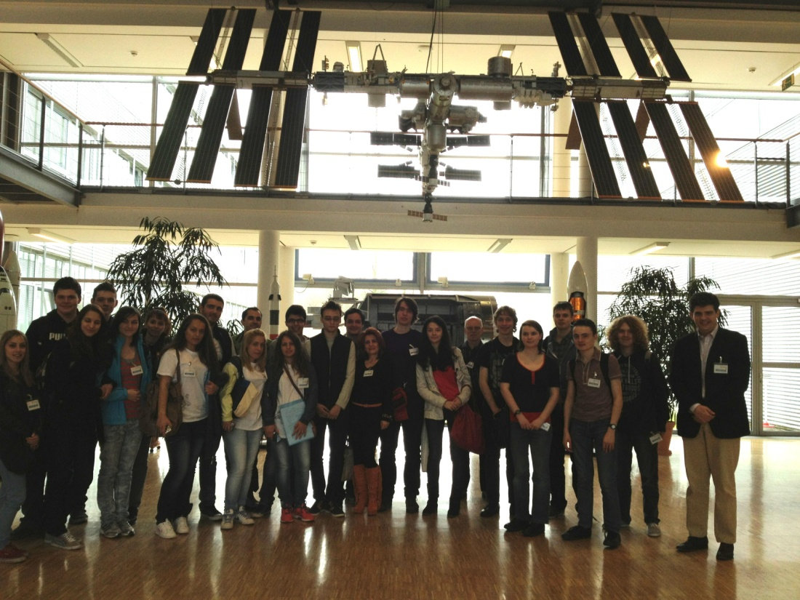

From the visit of the winning teams to the European Astronaut Centre

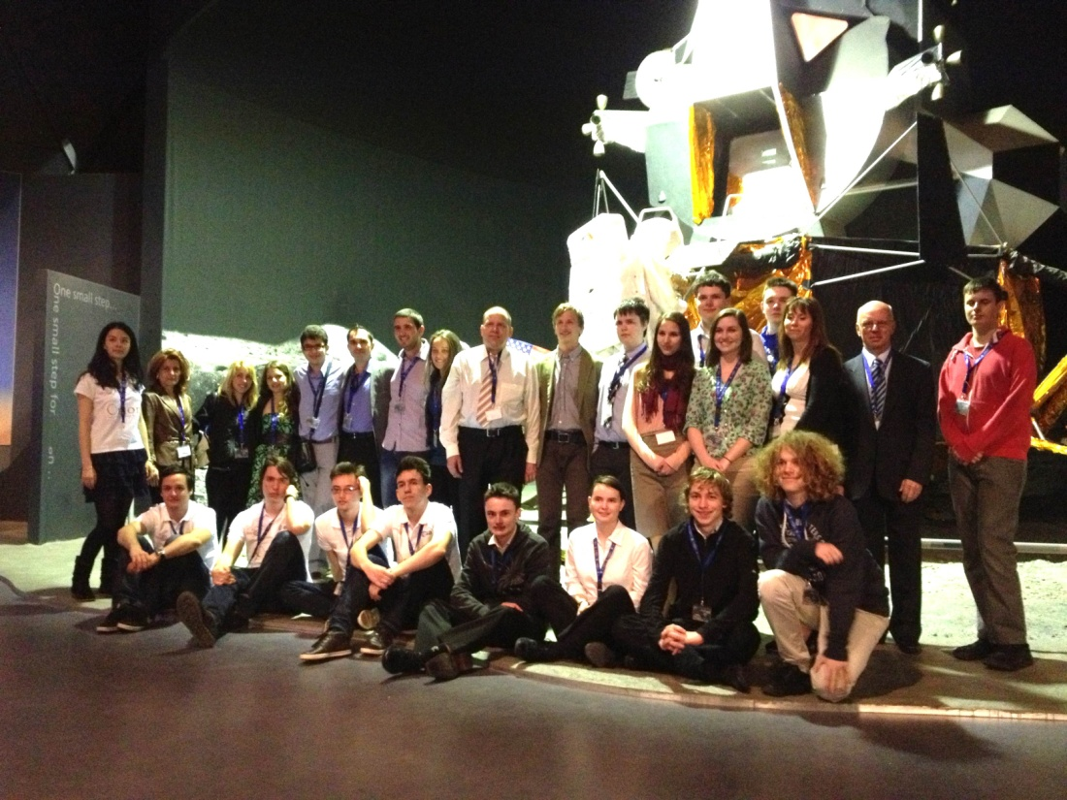

The winners after the award ceremony in Space Expo

