
Press Release

21 October 2013
---------------------------------------

www.eurofound.europa.eu @eurofound

Eurofound publishes draft report on minimum wages in Europe:
New Eurofound report evaluates potential impact of a coordinated EU minimum wage policy
(DUBLIN, IRELAND): Although minimum wages are set at national level and the EU has no competences on this matter, there is an on-going debate about the possibility of coordinating minimum wage policy across Member States, for instance by setting a common threshold of 60% of the median wage in each country. In the majority of EU Member States, minimum wages are set by government regulation. Germany together with Austria, Denmark, Finland, Italy and Sweden are the exceptions. In these countries minimum wages are set by collective bargaining agreements.
A new Eurofound report evaluates the potential impact of such a common minimum wage threshold estimating the number of workers potentially affected. The use of a common metric allows the evaluation and comparison of the existing systems and levels of minimum wages in Europe in a highly illustrative way. The country that stands out the most in this exercise is Germany.
According to this simple accounting exercise, Germany would be the EU country where a larger proportion of the workforce would see their wages increase with the establishment of a common EU threshold of 60% of the median (almost one in four German workers would be affected), as can be seen in Figure 1. The reason is, of course, that the share of low-paid workers in the German labour market is among the highest in the EU (relative to the median in each country).
Figure 1: Proportion of employees below the hypothetical EU minimum wage threshold of 60% of the national median wage
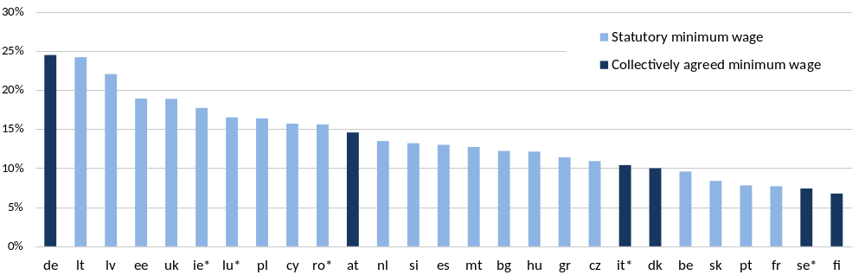
Source: EU-SILC 2010. In the countries indicated with asterisk, the EU-SILC and EU-SES surveys produced inconsistent results, so the values shown are the average of both sources.

In a majority of EU Member States, minimum wages are established by government regulation. Germany belongs to a second category of countries, in which minimum wages are directly established by collective agreement on a sector-specific basis. If we compare the German results with those of other countries in the same category (i.e. with collectively agreed minimum wages), the contrast is even more striking. Whereas in most countries with collectively agreed minimum wages the impact of establishing a common EU threshold would in quantitative terms be very small (since very few workers currently earn less than 60% of the median wage), in Germany it would be the largest of all. This is because in most cases, collectively agreed minimum wages tend to be associated with wage distributions with fewer low-paid workers except in the case of Germany. According to these results, therefore, Germany is an outlier not only in terms of the levels of low pay (and consequently, in terms of the large potential impact of an EU minimum wage policy), but also in terms of the functioning of the system of minimum wage setting (which does not seem to produce the same outcomes as in other countries in the same category).

The draft report is available at: http://www.eurofound.europa.eu/press/presspack/minimumwagesdraft.htm

For further information contact Måns Mårtensson, Media manager, on email: mma@eurofound.europa.eu telephone: +353-1-204 3124, or mobile: +353-876-593 507.

NOTES TO THE EDITOR
The European Foundation for the Improvement of Living and Working conditions (Eurofound) is a tripartite European Union Agency, whose role is to provide knowledge in the area of social and work-related policies. Eurofound was established in 1975 by Council Regulation (EEC) No. 1365/75.
For more information about Eurofound and its work, and free access to all our data and findings, visit our website and follow us on these social media channels: Twitter, Facebook, Google+, YouTube, or Flickr.

The data draws from two recent EU-wide surveys on income and wages, EU-SILC and EU-SES, from 2010.
Using EU-SILC 2010 data, Eurofound estimated the value of 60% of the median to be EUR 8.65 per hour in Germany, a figure close to the one currently being debated in that country. Because of inflation and changes in the distribution of earnings in Germany over the last three years, the share of workers below this threshold may be slightly different - albeit not altering the overall picture and comparative results.

